Assignment 2(DMSL)

1. Create Students Table

CREATE TABLE Students (
PRN INT PRIMARY KEY,
FirstName VARCHAR(50) NOT NULL,
LastName VARCHAR(50) NOT NULL,
MiddleName VARCHAR(50) NULL,
Year INT NOT NULL,
Email VARCHAR(100) UNIQUE,
Age INT NOT NULL,
Department VARCHAR(100) NOT NULL
);

2. Insert Records into Students Table

INSERT INTO Students (PRN, FirstName, LastName, MiddleName, Year, Email, Age, Department)
VALUES
(101, 'John', 'Doe', 'A.', 2, 'john.doe@example.com', 20, 'Computer Science'),
(102, 'Jane', 'Smith', 'B.', 1, 'jane.smith@example.com', 19, 'Electronics'),
(103, 'Alice', 'Johnson', NULL, 3, 'alice.johnson@example.com', 21, 'Mechanical'),
(104, 'Brod', 'Stud', 'B', 2, 'Brod.a@example.com', 20, 'Electronics'),
(105, 'Mark', 'Taylor', NULL, 1, 'mark.taylor@example.com', 18, 'Computer Science'),
(106, 'Emma', 'Clark', 'C.', 3, 'emma.clark@example.com', 22, 'Mechanical');

3. Retrieve All Records from Students Table

SELECT * FROM Students;
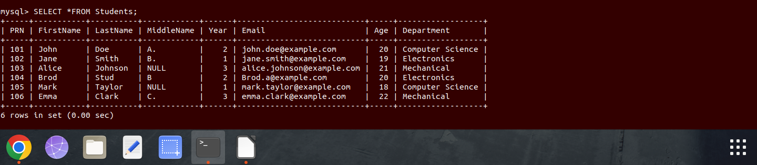

4. Update Year of Student with PRN 102
UPDATE Students
SET Year = 2
WHERE PRN = 102;
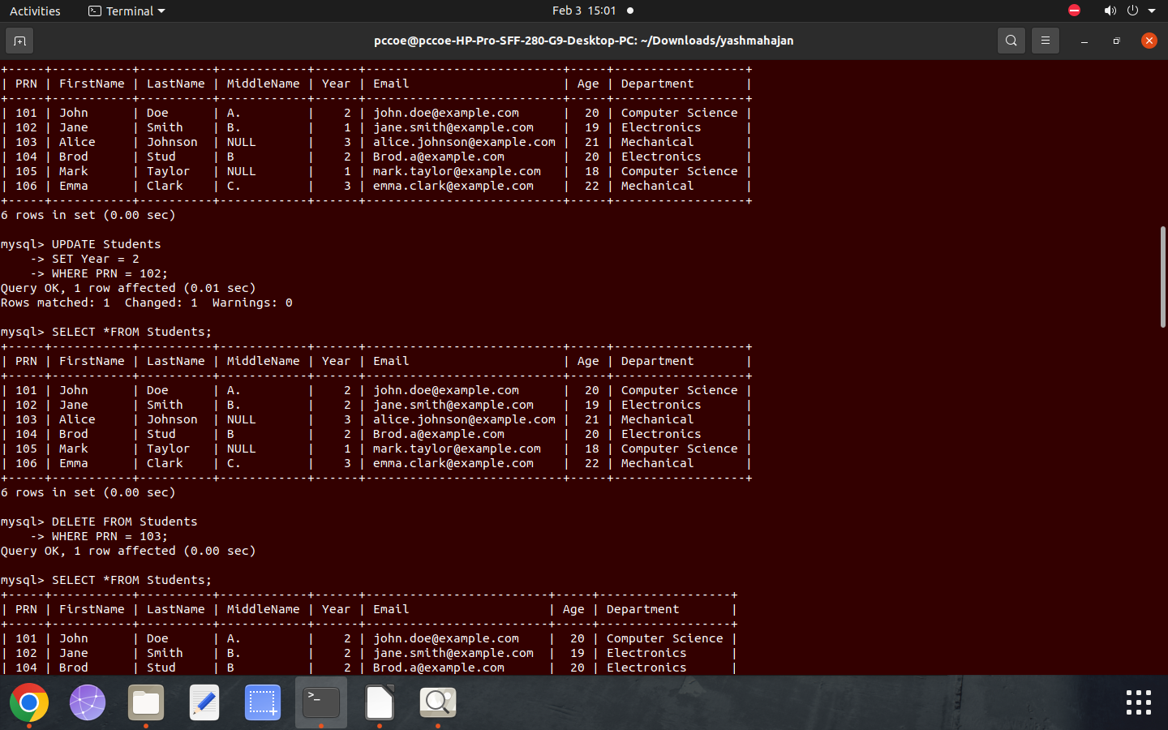

5. Delete Record of Student with PRN 103

DELETE FROM Students
WHERE PRN = 103;
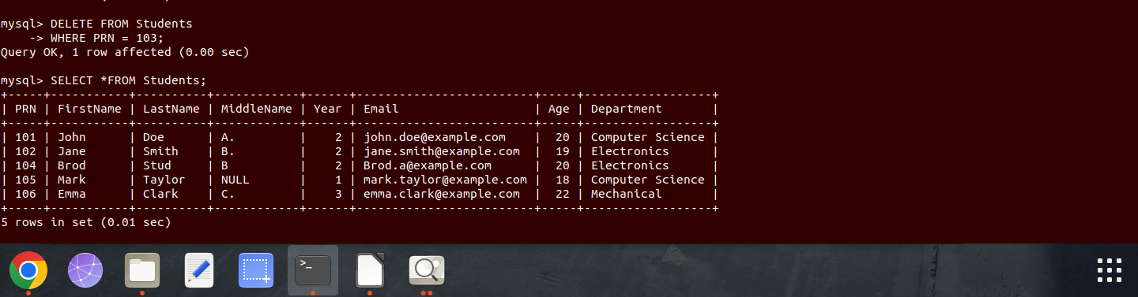
7. 6.Alter Students Table - Add PhoneNumber Column

ALTER TABLE Students
ADD COLUMN PhoneNumber VARCHAR(15);
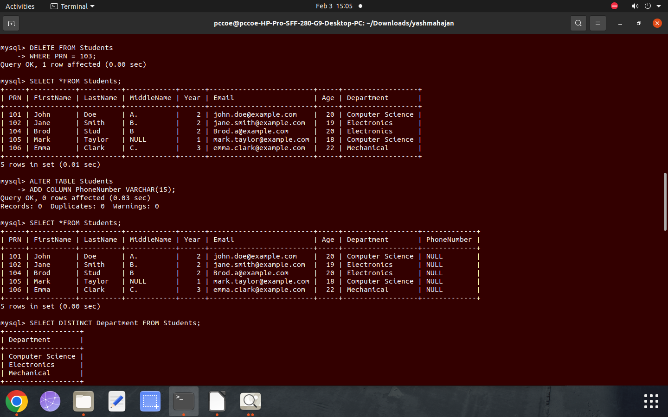
7.Retrieve All Distinct Departments
SELECT DISTINCT Department FROM Students;

8. Find Number of Distinct Departments

SELECT COUNT(DISTINCT Department) AS DistinctDepartments
FROM Students;
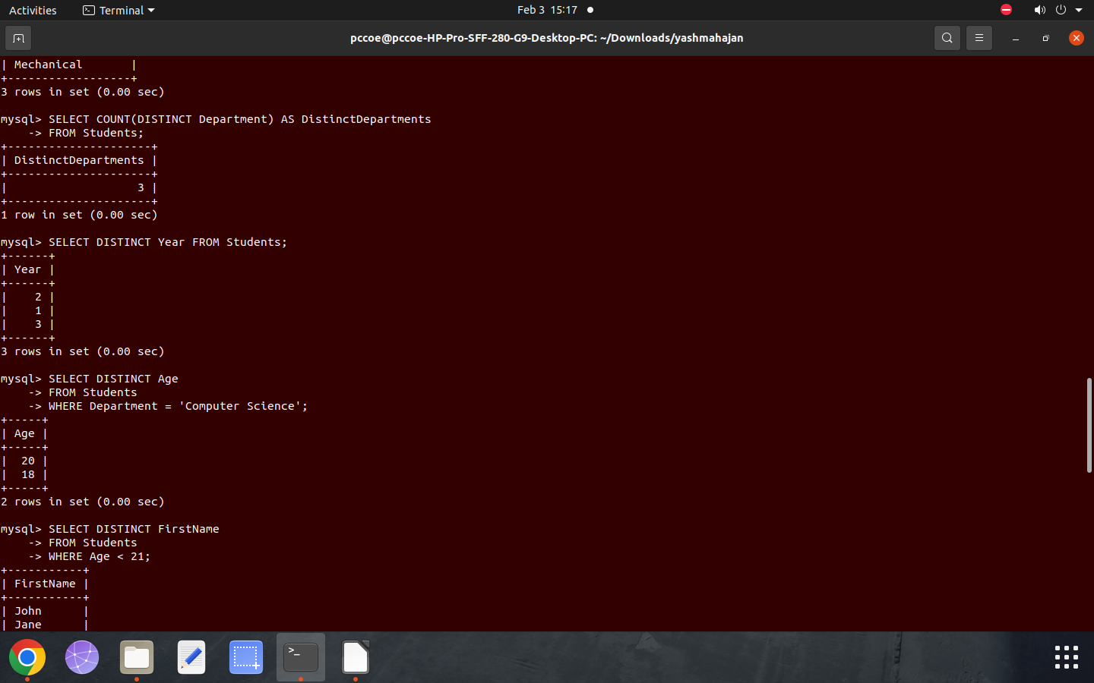

9. Retrieve Distinct Years in which Students are Enrolled
SELECT DISTINCT Year FROM Students;

10. Retrieve All Distinct Ages of Students in "Computer Science" Department

SELECT DISTINCT Age
FROM Students
WHERE Department = 'Computer Science';

11. Retrieve Distinct First Names of Students whose Age is Less than 21

SELECT DISTINCT FirstName
FROM Students
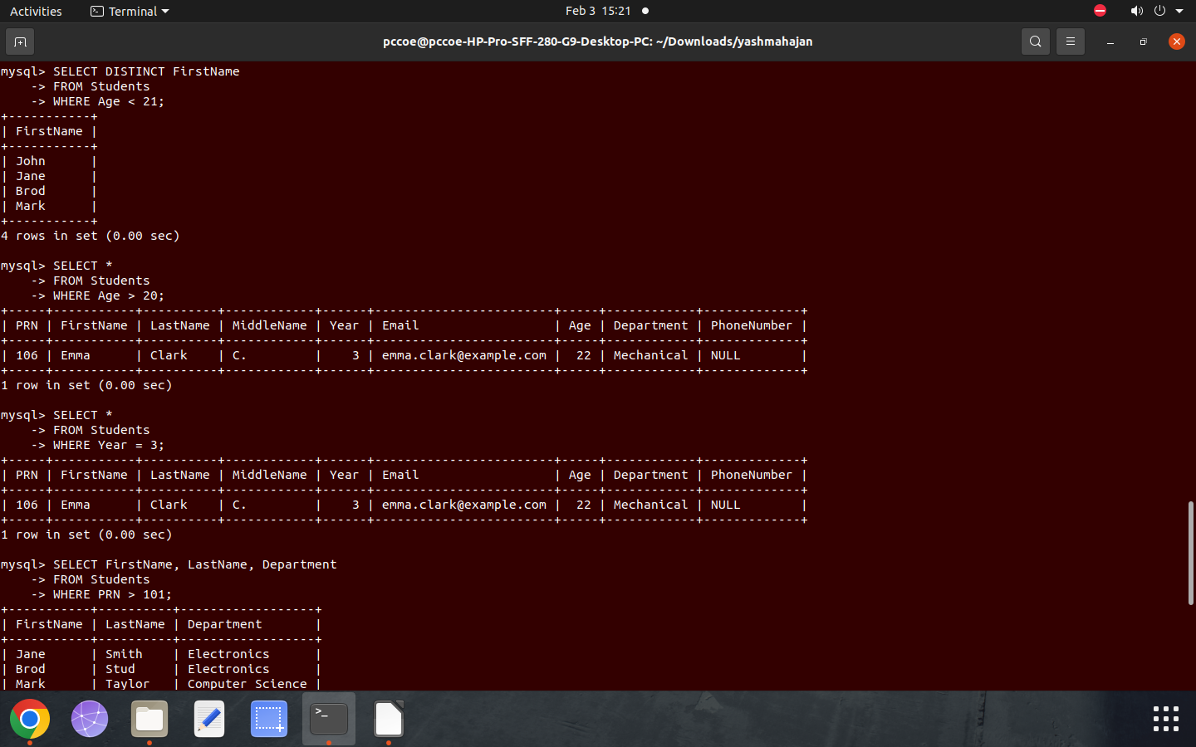
WHERE Age < 21;

12. Retrieve Full Details of Students Older than 20 Years

SELECT *
FROM Students
WHERE Age > 20;

13. Retrieve All Students Enrolled in their Third Year

SELECT *
FROM Students
WHERE Year = 3;

14. Retrieve First and Last Names with Department for Students with PRN Greater than 101

SELECT FirstName, LastName, Department
FROM Students
WHERE PRN > 101;
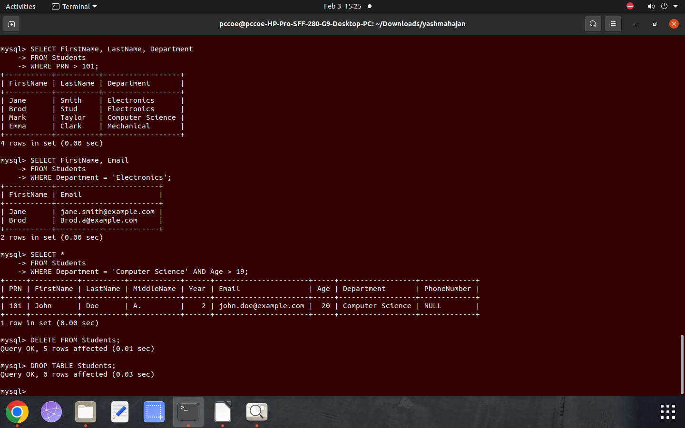

15. Fetch First Names and Email Addresses of All Students in "Electronics" Department

SELECT FirstName, Email
FROM Students
WHERE Department = 'Electronics';

16. Fetch Details of Students in "Computer Science" Department who are Older than 19

SELECT *
FROM Students
WHERE Department = 'Computer Science' AND Age > 19;

17. Remove All Records from Students Table (without deleting the table)

DELETE FROM Students;

18. Drop the Students Table

DROP TABLE Students;

